IPhone redesign

Rework of the front home screen

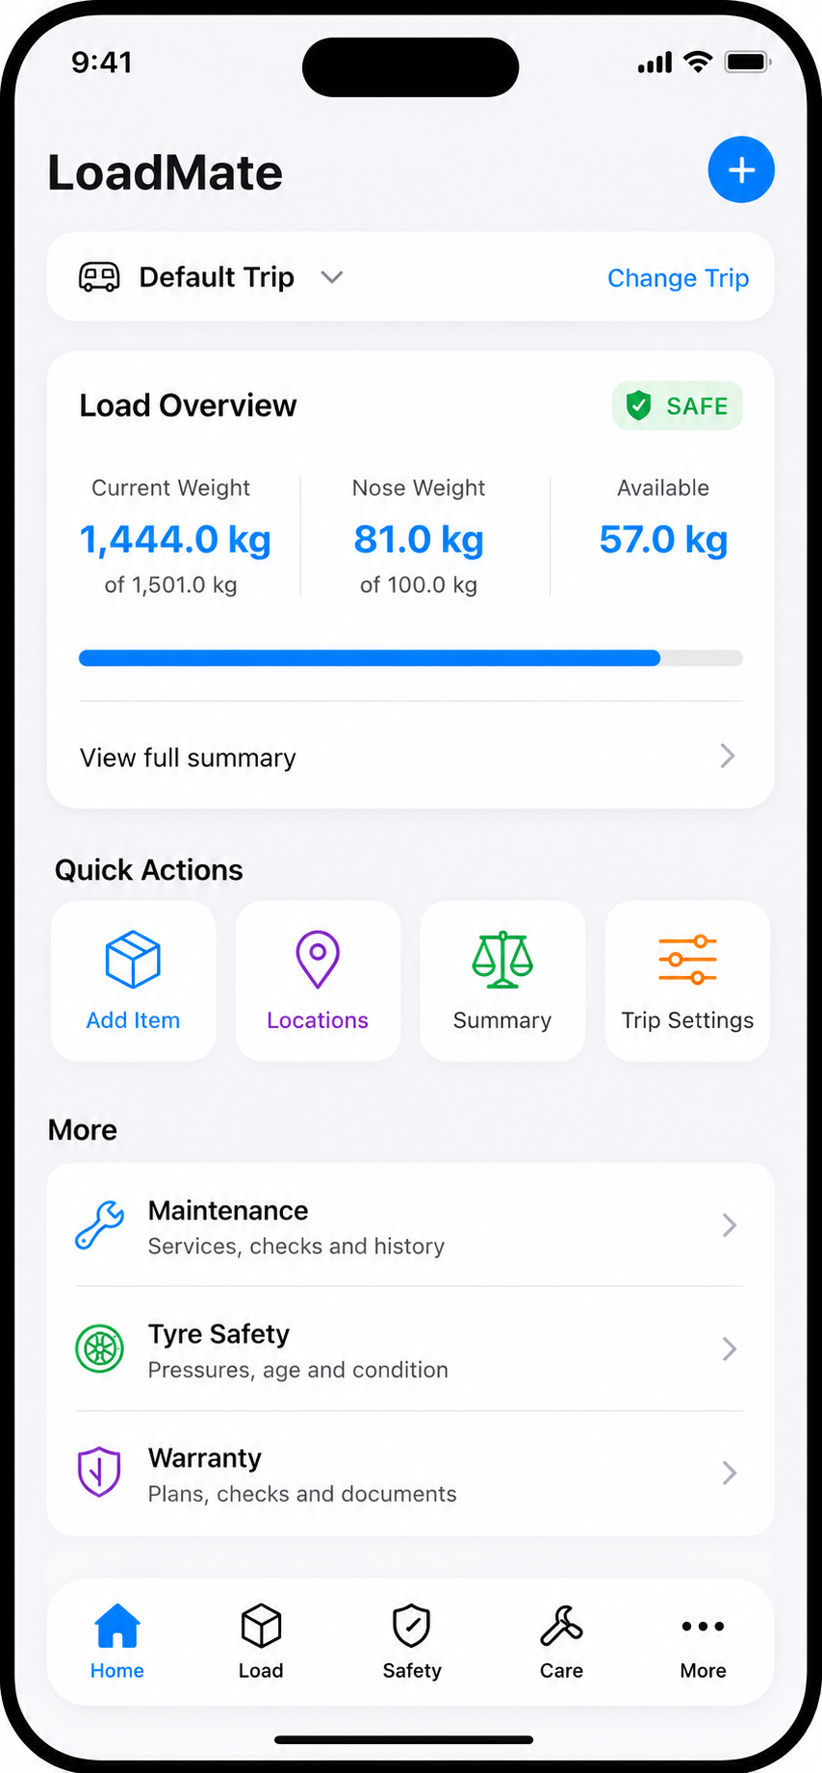

A new safety screen

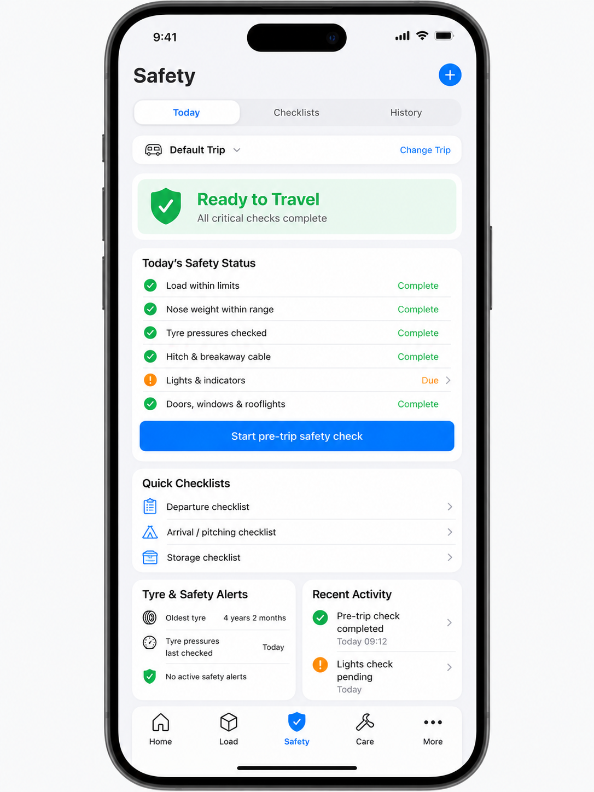

New tabled aoyt for loading, Bringing together loading, positioning, and summary

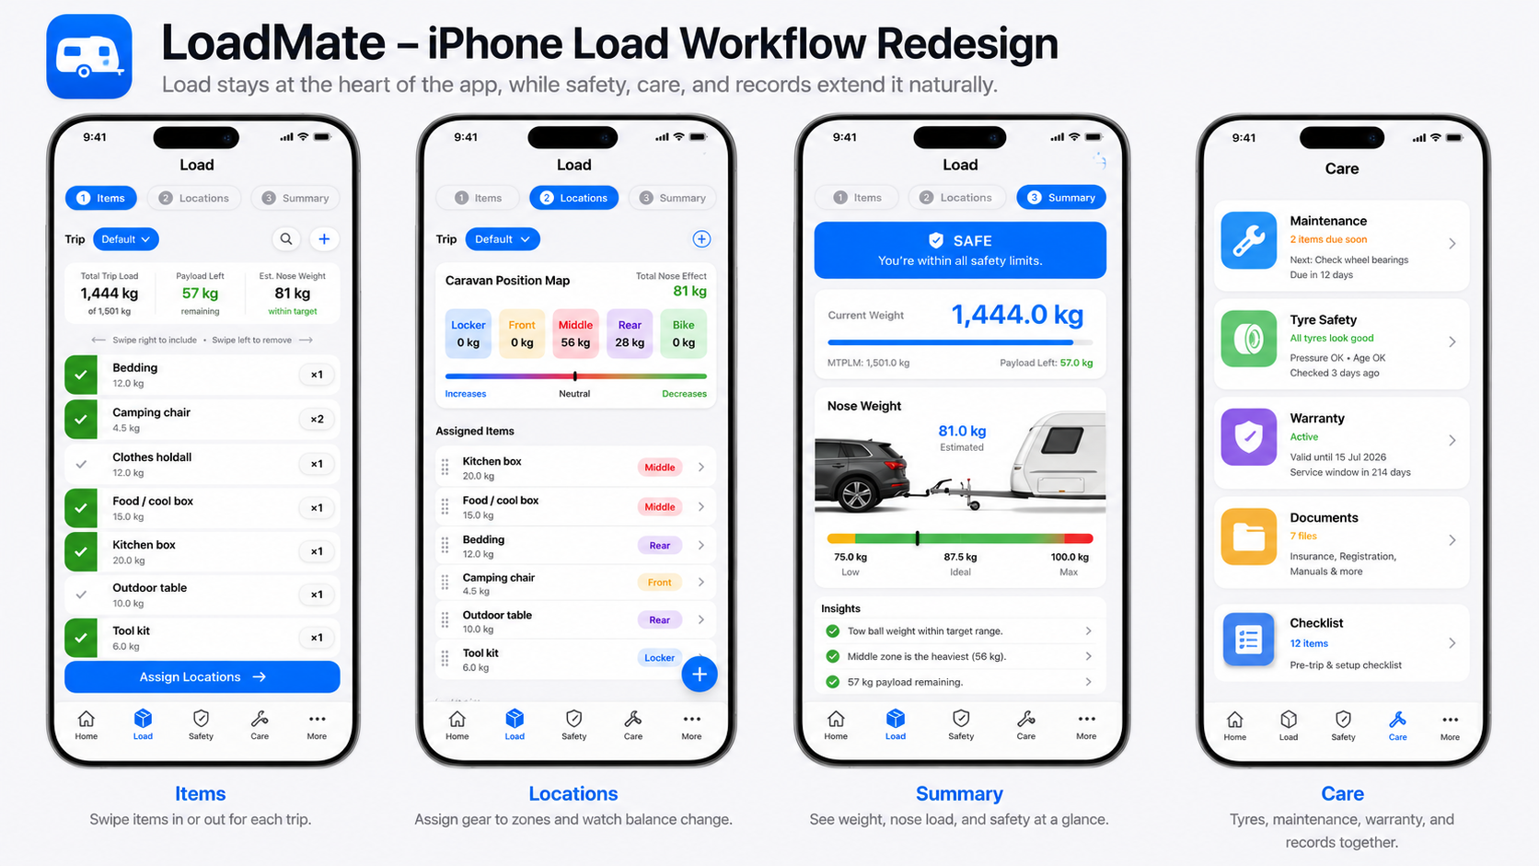

IPad redesign

